***Extreme Environments:***

***An Integrated Science Learning Unit for***

***Yukon Grade 6 Students***

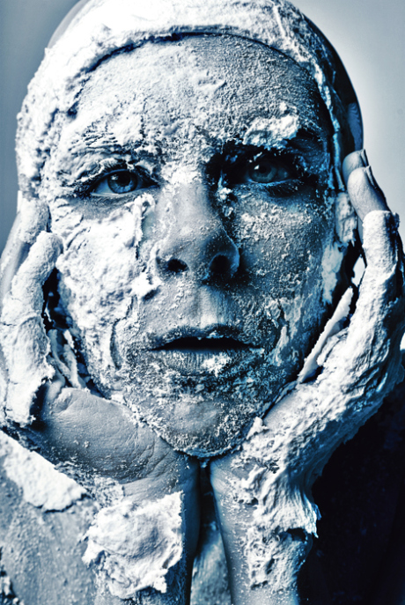

Centre for Youth, Research, Science Teaching and Learning

University of Manitoba

Social Sciences and Humanities Research Council

November 2013

***Table of Contents***

Topic Page

Acknowledgments 3

Guiding Principles of the Unit 4

Cross-Curricular Applications 5

Conceptual Ideas and Progression 7

Some Valuable Websites 8

Skills Development 9

Attitudes and Beliefs Development 10

Introducing the North as a “Extreme Environment” 11

Knowledge, Skills and Habits of Mind 20

Traditional Technologies for Our Extreme Environment 56

Other Cultures as Extremophiles 62

Other Living Things as Extremophiles 63

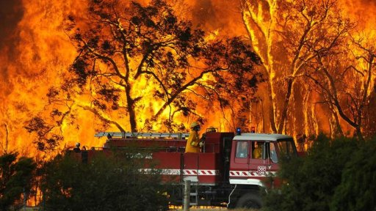 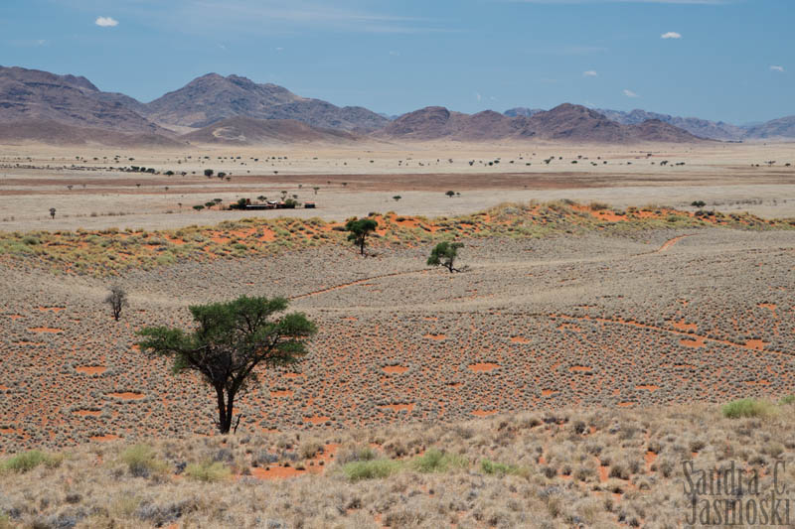 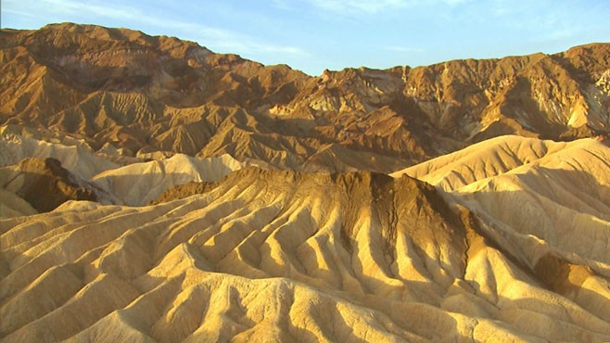

***Acknowledgments***

In 2008, the Yukon First Nation Education Advisory Committee proposed several goals and priorities for education in the Yukon. Central priorities included the development of curriculum and resources that integrate into curricula, First Nations content, perspectives, values, knowledge *and ways of teaching and learning.* This resource provides teachers with the support for providing learning experiences that allow for learning to be grounded in the heritage of northern students including culturally preferred learning styles rather than just learning about their heritage.

The development of this resource for teachers and students in the northern Yukon has been made possible through the granting agency Social Sciences and Humanities Research Council. Their support has ensured that northern students are provided with the opportunity to learn about their heritage through means responsive to their learning style preferences, especially when they study core curriculum areas such as science. The development of this resource has also been made possible through the support of the Tr'ondëk Hwëch'in community of Dawson City. The elders and community members have given their time and knowledge to ensure that their experiences can be recorded and incorporated into learning activities valuable for their community’s children.

As well, the school community of Robert Service School, especially the teachers of the Intermediate grades is thanked for its support in the development of the learning activities outlined in this resource.

Contact details:

Dr. Brian Lewthwaite

Faculty of Education

University of Manitoba

**Guiding Principles of the Unit**

* Draw upon teaching orientations that are identified as culturally located practices.
* Affirm cultural competencies honored by the local community.
* Provide two-way learning experiences by integrating traditional knowledge, beliefs and values and contemporary scientific knowledge, processes and attitudes.
* Use traditional and contemporary cultural examples as contexts for student learning.
* Include the local community and its people in students‟ learning opportunities, especially in the use of narratives including local people.
* Foster Han language development where possible.
* Use diagnostic and formative assessment to inform planning and teaching and monitor student learning.
* Engage students by starting lessons by providing first-hand experiences for students or drawing upon common experience.
* When using story to engage students, use the interrupted-story-line as a vehicle to prompt consideration and first-hand investigations.
* Deliberately promote scientific attitudes of mind (curiosity, problem-solving, working to end) student through thoughtful independent consideration of questions and challenges posed.
* Move from the experiential, first-hand experiences to the psychological; that is, after providing concrete experiences assist students in making sense of experiences by using purposeful strategies to promote understanding such as role plays, illustrations and analogies.
* Assist students in their consolidation of ideas only as an extension of the initial experiential and psychological learning experiences.
* Provide opportunities for student-initiated and directed investigations.
* Provide opportunity for students to make connections among science and all other learning areas.
* Foster student independence, creativity and curiosity by providing opportunity for students‟ ideas and questions and follow-up opportunities for problem-solving and investigation.
* Provide students the opportunity to make connections between what they are learning and career opportunities specific to the local

***Cross-Curricular Applications***

This unit is developed to reinforce learning outcomes of Science, Social Studies and English Language Arts relating to the Science unit of Extreme Environments, experienced during Grade 6. These include:

***Extreme Environments***

*It is expected that students will:*

* Explain obstacles to life and exploration in extreme environments;
* Assess technologies for extreme environments;
* Describe contributions of Canadians to survival and exploration technologies.

The unit is also developed to reinforce or address the learning outcomes of the Social Studies and English Language Arts curriculum of British Columbia (2005). The emphasis in Social Studies on the validation of Aboriginal Cultures and Continuity and Change in Society are emphasized in this unit. As students are engaged in science, they will also be engaged in social studies learning. They will also be developing oral and written language and numeracy skills specific to Grade 6. Students are encouraged to explore the characteristics of extreme environments through the stories and accounts of persons from the community, hands on experiments, and questioning. By hearing these accounts and having their own first-hand experiences, students can develop a rich appreciation of their local environment and the actions that will lead to a safe and productive life in this environment. There are obvious connections to social and environmental change and personal health and well-being. Broaden the focus by adding stories and activities of your own or from the experiential base of your community.

***Social Studies Skills and Processes:***

*It is expected that students will:*

* apply critical thinking skills –including comparing, classifying, inferring, imagining, verifying, identifying relationships, summarizing, and drawing conclusions – to a range of problems and issues.
* interpret graphs, tables, aerial photos, and various types of map evaluate the credibility and reliability of selected sources
* deliver a formal presentation implement a plan of action to address a selected local or global problem or issue
* use an outline to organize information into a coherent format.

***English Language Arts: Oral Language (Purposes, Strategies, Thinking and Features)***

*It is expected that students will:*

* Share ideas relevant to class activities and discussions.
* Listen to classmates and others without interrupting.
* Speak respectfully and use appropriate language and tone when disagreeing.
* Speak and listen in partner, small group, and whole class discussion to accomplish a task.
* Contribute relevant responses to class/group discussions.
* Use vocabulary appropriate to topic and audience. (ex. Using the appropriate terminology when referring to the different parts of the body)
* Follow multi-step oral instructions and demonstrations (conducting and experiments to understand how the human body systems function)
* Ask questions, independently or with classmates, to explore a

topic further.

* Use new vocabulary introduced in texts and class discussions.
* Build on others’ ideas.
* Question and speculate on possibilities regarding the ideas and information presented (e.g., “What if...,” “I wonder if...,”

“What would happen if...”)

***English Language Arts: Reading and Viewing (Purposes, Strategies, Thinking and Features)***

*It is expected that students will:*

* Follow written procedures
* Extract accurate and important information from text and ‘text features’, including specific details from graphics.
* Interpret images and make some relevant inferences (e.g. construct meaning from visual texts and identify relevant detail)
* Write down and/or share what they already know about a topic or idea and ask and respond to questions related to the material read/viewed.

***Conceptual Ideas and Progression***

The recommended sequence for supporting student conceptual development of the human body systems is suggested below. For the most part, the activities and the conceptual and skill development embedded within the activities are sequential. Lower elementary experiences and ideas primarily focus on experiencing and communicating these experiences. Upper elementary experiences focus on understanding and investigating these experiences and appreciating applications of this understanding to their students’ everyday world. It is suggested teachers address the following key ideas:

1. **We live in an extreme environment;**
2. **There are many stories told about this environment that we can learn from;**
3. **There are knowledge, skills and habits of mind that support our safety and survival;**
4. **There are many technologies developed specifically for this environment that support our safety and survival;**
5. **There are other extreme environments where knowledge, skills, habits of mind and technologies support safety and survival;**
6. **In our northern extreme environment, we see evidence of knowledge, skills, habits of mind and technologies that support other life forms’ safety and survival.**

The central theme in the learning is focused on developing the knowledge, skills and habits of mind that support living safely and successfully in a northern extreme environment.

**Some Valuable Websites**

National Geographic Adventure Travel

<http://adventure.nationalgeographic.com/adventure/>

National Geographic Alone in the Wild (Yukon Series)

<http://channel.nationalgeographic.com/channel/episodes/can-i-survive/>

National Geographic How to Survive Almost Anything

<http://www.nationalgeographic.com/adventure/survival/skills/>

Discovery Channel The Miracle of Snow

<http://dsc.discovery.com/video-topics/other/snow.htm>

Discovery Channel Survivor Man

<http://dsc.discovery.com/tv-shows/survivorman>

National Geographic Weather 101

<http://video.nationalgeographic.com.au/video/science/earth-sci/weather-101-sci/>

National Geographic The Best Survival Story Never Heard (Antarctic)

<http://video.nationalgeographic.com.au/video/specials/nat-geo-live-specials/roberts-antarctica-lecture-nglive2/>

National Geographic Life Below Zero

<http://channel.nationalgeographic.com/channel/life-below-zero/>

*Skills Development*

This unit emphasizes that the learning of science ideas is inextricably linked to the development of the processes of science. As asserted by British Columbia Science Grade 6 (2005), the legislated curriculum for Yukon schools, science experiences should provide opportunity for the development of conceptual understanding within the context of relevant investigative experiences. Although individual scientific process skills may be emphasized in specific activities, they are to be supported more holistically in teacher-facilitated or student-directed inquiry. The skills to be developed are expected to be appropriate to the level of the learner. These skills and a typical developmental sequence are outlined in detail in the Science Grade 6 (2005) guide. These skills involve coordination between cognitive and psychomotor skills. Handling and manipulating equipment require not just the physical ability to perform a task but also the intellect to know how to measure or observe accurately. It is anticipated that by the end of intermediate school, a student might be able to, with assistance, conduct a scientific investigation. This unit provides opportunities for students to work physically and cognitively towards this end.

There is no universal list of scientific process skills. Those identified in this curriculum are not intended to be a linear scope and sequence; instead, they suggest multiple ways in which learning science can be explored. At each grade level, two processes are introduced and then reinforced with the curriculum content in the subsequent grades; but teachers are expected to involve all of the skills their students are capable of using. Process skills are best learned in hands-on activities where students engage in a problem-solving task while doing science. The hands-on model of learning science allows students to construct meaningful connections within the brain. In young children, process skills can be found in the natural practice of manipulating materials while asking questions and being curious. The names of the skills can be used and reinforced by teachers as students use and learn to apply these skills to science activities. The science process names will become familiar to students, enabling them to use the correct vocabulary when they explain their involvement in science and technology inquiries.

*Attitudes and Beliefs Development*

An explicit goal in the development of this resource and the other resources being developed in this northern Yukon project and the accompanying professional development provided for teachers is to use these as a vehicle to contribute to student ‘success’ in science. Although success in science is often attributed to measurable outcomes such as knowledge acquisition and development, the intent of this development project is much more encompassing. It extends this notion of success to investigate the influence of ‘two-way’ learning experiences on students’ perceptions of success in their personal attitudes and beliefs, especially in how they see themselves as learners in formal learning settings. A key intention of this project is to investigate whether student engagement in learning is influenced by culturally located cultural practices.

What does success in science mean to northern Yukon students? It is anticipated that students will experience success in a variety of ways, beyond the border of knowledge into the domain of attitudes and beliefs. Attitudes are regarded as states of mind, behavior or conduct regarding some matter, as indicating opinion or purpose. The program of study suggested in the activities that follow will foster student curiosity and creativity, and openness to new ideas of thinking. As well students will develop confidence in their perceptions of self as students learning in formal school settings and, especially, in science. Similarly they will develop confidence as evidenced in risk-taking and their effort to conduct science investigations. Their participation in the processes of science will foster their perseverance, precision and objectivity in solving scientific problems. As members of a team they will develop in their respect for and ability to work co-operatively towards purposeful goals with their peers. The central theme in the learning is focused on developing the knowledge, skills and habits of mind, many of which are science based that support living safely and successfully in a northern extreme environment

Above all, it is anticipated that students will develop a more positive sense of themselves in contemporary society as they learn about the inextricable link between science and the world in which they live. It is anticipated that students will see science as part of their life trajectory both in future formal and informal settings as a result of science study that advocates ‘two-way’ learning

**Introducing the Yukon Environment**

**A Conversation with Angie Joseph-Rear**

In those days we would go in winter to Eagle in Alaska, down the Yukon River. We would go by dog team – my father, my mother, my sisters and brothers. It was a lot of work to get the whole family there and you had to be well-prepared. There were no roads in those days so you had to be really prepared to travel by dog team. Not like now when you travel by skidoo or truck, when you decide to go today and then you travel right away or maybe tomorrow.

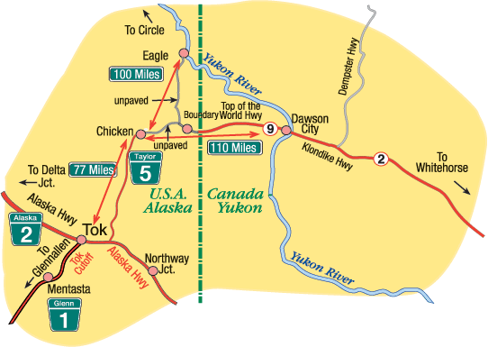

We would leave from Moosehide and we would have to prepare for days. The dogs had to be prepared. They had to be well fed. The harnesses had to be in good shape. We had to take food. We had to take fire starter. We had to take warm clothing. We would take dried meat, pemmican, lard, sugar, flour, and macaroni. The dogs would have fish – salmon – that was good for their energy – they were working dogs. Maybe we would hunt along the way – for small game like grouse, rabbits and ptarmigan, and even set snares. You were on your own.

[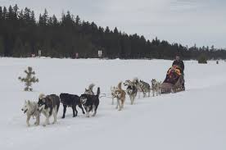](http://www.google.com.au/imgres?start=325&sa=X&rlz=1T4RLTB_enAU530AU539&biw=1366&bih=566&tbm=isch&tbnid=bUXWnN6HL5VLyM:&imgrefurl=http://www.goexplorenature.com/2011/03/dog-sledding-with-kids-in-mammoth-lakes.html&docid=yAtCB58cCDgcKM&imgurl=https://lh4.googleusercontent.com/-f_5vL-NJhWI/TXcS3avz1yI/AAAAAAAACKc/bhvI_MYx-40/s1600/Dog-Sledding.jpg&w=640&h=425&ei=6waMUqyJJsiKiAKWvICYAQ&zoom=1&iact=hc&vpx=108&vpy=53&dur=1409&hovh=183&hovw=276&tx=145&ty=104&page=14&tbnh=153&tbnw=224&ndsp=28&ved=1t:429,r:40,s:300,i:124)

We would camp at night, maybe in a cabin or a wall tent, maybe even a lean-to made from spruce boughs. If the weather started to turn bad, we would set up camp. You had to be prepared. It was cold, but we were prepared. You always made sure you made good decisions. If you weren’t prepared or made bad decisions, then trouble might happen. I do not remember bad things happening.

**Introducing the Yukon Environment**

**A Conversation with Victor Henry**

I used to haul fuel and supplies by truck in the Yukon. In winter-time you had to be really careful. You had to be prepared for what might come. I would always take food with me, hot drinks, a sleeping bag, warm clothes, even birch-bark fire lighter. The truck had to be checked thoroughly – there was no room for error. The trips sometimes did not take too long. Even though they did not take too long, you had to be prepared. Often there was no one on the highways so you were on your own.

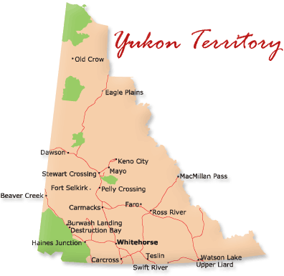 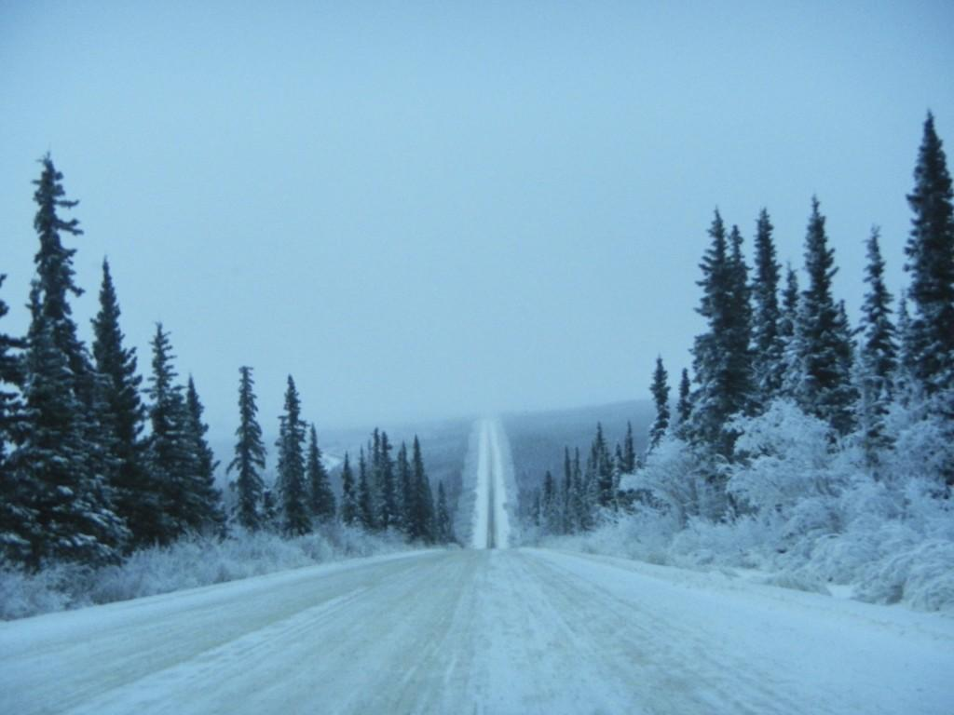

One day I was hauling to Stewart Crossing. When I left Dawson around 1 p.m., it was not that cold, but as I went through Gravel Lake area, it started to get really, really cold. I heard later it was minus -48. I was only about 8 kilometres from Stewart when the truck started to slow down. It wasn’t getting any gas. I think the fuel line was freezing up. Soon, the truck came to a stop and it would not start.

I thought about what I should do. I put on all my warm clothing and then decided I’d walk to Stewart. I started to walk and then realized it might take me three hours to get there and it was so cold. I turned around and went back to the truck. I got out my survival gear – rope, an axe, matches, starter, billy, food (Klik), sleeping bag - and lit a fire using the birch bark. It started right away.

I made a lean-to near the fire. It was really warm, even though the temperature was so cold. In the night, no one came. I kept the fire going. I used the food sparingly. Later the next morning another trucker came along and gave me a lift into Stewart. I knew I had made the right decision.

In the two stories there are some **similarities** and **differences** told by Victor and Angie about their experiences**. What are they? In the chart below list the similarities and differences?**

|  |  |
| --- | --- |
| What is the **same in the stories?** | What is **different in the stories?** |
|  |  |
|  |  |
|  |  |
|  |  |
|  |  |
|  |  |

What is the **main thing** they are both saying? What is their most important message?

From their stories, **what is necessary to survive in a northern extreme environment, at least for a short time?**

|  |  |
| --- | --- |
| What objects should I have with me? |  |
| What knowledge do I need? |  |
| What are some of the skills I need? |  |
| What ‘habit of mind’ do I need? |  |

**The Yukon Environment: An Extreme Environment**

In this unit, we will be studying the Yukon as an **extreme** environment. In preparation for the unit, ask family at home to share stories about life in the Yukon. Get them to tell you stories of experiences they have had that show the extremes of the Yukon environment. The word extreme means “**exceeding the ordinary, usual, or expected**”. Most people are not aware of how cold the Yukon northern region is and the extremes of the temperatures. In fact, the coldest reported temperature in Canada was recorded in Snag, Yukon, 30 km south of Beaver Creek. On February 3, 1947, the record-low temperature for continental North America was recorded in Snag: −63 °C. That same winter, two previous records had already been set: one on December 13 in Mayo, Yukon and another at Snag the day before. Staff at the station made note of various phenomena, particularly sound such as voices being heard clearly miles from their source. There was a clear sky (except for some ice fog), and little wind. There were 38.1 centimetres of snow on the ground, but was fast decreasing. Another town 180 km northeast of Snag, Fort Selkirk, claimed an even lower temperature of −65 °C, but this could not be confirmed.

An **extreme environment** exhibits conditions which **are challenging for most life forms**. These may be extremely high or low ranges of temperature, radiation, acidity, air, water, salt, sulfur, petroleum and many others.

**An extreme environment is one place where humans generally do not live or could die there**. There are organisms referred to as **extremophiles** that inhabit these spaces and are so well-adapted that they readily grow and multiply.

Examples of extreme environments include the geographical poles and arctic regions, very dry deserts, volcanoes, deep ocean trenches, upper atmosphere, St Elias Mountains, outer space and other planets. The organisms living in these conditions are very well adapted to their living circumstances, which is usually a result of long term evolution.

**Types of Extreme Environments** are alkaline, acidic, extremely cold, extremely hot, or hyper-saline places without water or oxygen. They can also be places altered by humans. Examples of **places altered by humans** are mine tailings or oil impacted habitats. Before humans were around there were extreme environments covering our planet everywhere. Most of the moons and planets in our solar system are also extreme environments. Scientists have found life in these environments and have started to learn new things about earth's history.

**Key Learning Words**

Use the space below to list all the words you encounter in this unit that have to do with extreme environments.

|  |
| --- |
|  |

**Temperatures in Dawson: A Land of Extremes**

### Daily High and Low Temperature for Dawson City, Yukon

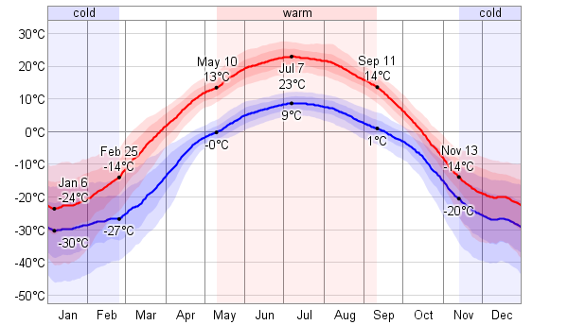

1. What is the coldest month of the year?
2. What is the warmest month of the year?
3. What is the average low temperature for January?
4. What is the average high temperature for January?
5. What is the average low temperature for July?
6. What is the average high temperature for July?
7. What is the temperature **difference** between the lowest temperature in January and the warmest temperature in July?
8. For how many months of a year is the lowest temperature below 0 degrees – that is, how many months do we have that are ‘frost-free’?
9. This number of months determines our ‘growing season’. Approximately how many days long is our growing season? This gives us reason for describing our location as ‘extreme’.

**Being Prepared and Respectful**

*Based on an interview with Dick Field of Dawson City*

|  |
| --- |
| I was raised to respect the land we live in. You always have to be prepared when you head off on trips because this land is unforgiving. You are not a wise person if you don’t give it the respect it requires. I was raised that way, but an event occurred in my life when I was a young man that taught me I wasn’t that respectful or wise.  http://www.photolib.noaa.gov/bigs/theb0794.jpg  We were living in Aklavik and there was still ice on the river after breakup. I was the driver of a boat and my sister was in it. We got caught in the ice and the boat capsized from the pressure of the ice floes and she drowned. It was an event that shouldn’t have happened because I shouldn’t have been out in the water when it was still with ice. It was too dangerous but I did not listen to what I knew was good advice. I knew that but I didn’t listen to what I knew.  They looked for my sister in the ice. It was a very difficult time for everyone. I will never forget that day. It should not have happened.  That simple error cost me and my family greatly. That event reminds me through my entire live to not just be prepared but also respectful. When you are preparing, you are showing respect. |

*Based on an interview with Alfred Kendi of Fort McPherson*

|  |
| --- |
| You learn that you have to respect the weather. It is not something you can just ignore. You grow up in the north hearing stories about how people have got in trouble and there have been tragedies because people have taken the weather for granted.  I know my father told me that I had to respect the environment and be sure to just ask God for travelling safety because things can change so much and so fast. It’s like if you see yourself better than the environment or stronger than it, you are asking for trouble. Be careful, be well planned, be respectful, be wise - don’t take things for granted - that is what is important. If you don’t know how to get somewhere, just don’t head off thinking you will get there. You need to ask for advice.  I think the story of the Lost Patrol and the death of the RCMP going from Fort McPherson to Dawson City is an important one. The police were told to be careful and not be too confident in their own ability. I think they might have been too confident and should have listened to advice.  DSC_6892_Lost_Patrol_gravesite  The "Lost Patrol" had set out from Fort McPherson, N.W.T., Dec. 21, 1910, heading for Dawson, Yukon Territory, a trek of roughly 800 kilometers (500 miles). Failing to find their way through the mountains, the lost patrol had turned back to Fort McPherson in a desperate race against cold and starvation. The grisly discoveries of the bodies of Taylor and Kinney, then Carter and Fitzgerald, were all made within 50 km of Fort McPherson on March 21-22, 1911. They are now buried in Fort McPherson. |

*Based on an Interview with Zachariasie PANIPPAKUTTUK of Igloolik*

To understand the tragedies that happen in the north you need to understand SILA. Across the north people refer to SILA.

It is more than the weather; it is more like the person who is the weather. It is greater than us all. It is like it is the person who is in our atmosphere.

SILA is an old word. I am not certain what it is but SILA has to do with anything outdoors including the weather. A child must understand the outdoors and being sent outside to see SILA in the morning was part of the training. Upon returning indoors, we would always be asked how the weather was (SILA). We would say SILAALUK to describe the atmosphere and the sky above us or the surrounding.

The word SILA is used much in the language of the north, especially amongst Inuit. From the word SILA we can have meaning meanings, for instance SILAITTUQ a person who is not very smart or has a small amount of SILA. SILATUJUAALUK means a wise person, or a person with huge SILA. This is the type of an individual who has a reasoning capacity of the huge mass of SILA. That person has spent much time observing others and listening to others - always being open to learn.

But being smart and wise was about being respectful and prepared – not being overly confident. Too many people today are SILATTUQ. It can’t be learned from a book. Schools do not teach someone to be SILATUJUAALUK.

SILA could be angry. When there was bad weather it was always believed to be associated with someone breaking a taboo. Taboos are things that cannot be done. Should someone breach a certain taboo, their life would change. Perhaps they would get some kind of an illness or it might have an effect on the game animal that they hunted or it might change the weather because one person had breached a taboo. This was the most common occurrence when certain taboo had been breached. This is what was believed.

If someone was not being prepared for a trip they were without having SILA and something bad could happen.

**There are knowledge, skills and habits of mind that support our safety and survival in extreme environments**

**Understanding Frostbite:**

|  |
| --- |
| This is a story I would like to tell young people, but I would prefer for my name not to be mentioned.  I was in Mayo. I travelled to Mayo in winter to get a job at the Keno mine. I met some young people there who were also there to get a job. In those days you just needed to show up and they would hire you and put you to work. Someone had alcohol and I drank some. In fact, I drank too much. It was night time and there was much drinking.  For some reason I decided to go outside. I only had my jean jacket on and it was very cold, maybe -30 degrees. Even though I had on light clothing, I felt warm and sleepy and decided to sit down in the snow to rest.  I woke up much later. It was still night time. I could not feel my fingers. I touched my face and I could not feel my face, or my ears.    I went back to the house where we had been drinking and the party was still on. They said my face was all white. It was frozen.  The next day my fingers and face was so painful. They started to blister. I went to the doctor and he said I had frostbite. He told me I would lose my skin and maybe one of my ears. He gave me penicillin because he said infection might set in.  I went to work but for days it was very painful. The skin did come off, but I did not lose my ears. They went black. I know there are many people that have lost toes and fingers or even frozen to death because of doing what I did. I am very fortunate I did not die. |

Frostbite is literally the freezing of body tissue (usually skin). The body is mainly composed of water and so, below 0 degrees, if parts of our body are exposed to the air, they will freeze. Fingers, toes, ears, and the nose are the areas most vulnerable to frostbite.

There are three degrees of frostbite, including:

* **Frostnip**, which usually affects the face, ears, or fingertips. While the skin may feel numb, frostnip does not lead to permanent tissue damage.
* **Superficial frostbite**, in which the outer skin is affected.
* **Deep frostbite**, in which the skin and underlying tissue freezes. Permanent damage is possible, depending on how long and how deeply the tissue is frozen.

Frostbite is caused by either prolonged exposure to cold temperatures or shorter exposure to very cold temperatures.

### What are the symptoms?

Many people with frostnip or frostbite experience numbness. A "pins and needles" sensation, severe pain, itching, and burning are all common when the affected area is warmed and blood starts flowing again. Skin may look white, grayish-yellow, or even black with severe frostbite, and it may feel hard, waxy, and numb. Blistering is also common.

### Who is at risk?

Anyone can end up with frostbite if exposed to frigid conditions for too long. Naturally, those who work outside in the cold or engage in cold-weather sports may be vulnerable if they aren't adequately prepared.

### Tips:

1. Do not expose skin to the air for any long periods of time.
2. *DO NOT* allow thawed tissue to freeze again. The more often tissue freezes and thaws, the deeper the damage. If the victim will soon be exposed to freezing temperatures again, wait to treat frostbite.
3. *DO NOT* use any heating devices, stoves, or fires to treat frostbite. Victims cannot feel the frostbitten tissue and can be burned easily.
4. In a pinch, body heat can be used to thaw mild frostbite or frost nip (tissues that are not quite frozen yet). For example, place mildly frostbitten fingers under the arm to keep warm.

**Understanding Hypothermia: An adapted story from Victor Henry**

|  |
| --- |
| We were travelling from Dawson to Stewart by dog team. I had my team and my father had his. It was a cold day in spring. In some places there was open water so we needed to be careful.  [http://ts1.mm.bing.net/th?id=H.4516717659358952&w=214&h=79&c=7&rs=1&pid=1.7](http://www.bing.com/images/search?q=dog+team+and+crossing+open+water&FORM=HDRSC2#view=detail&id=7D65FB94C59B692FCF0E39A6F0DA2BB26C791BB5&selectedIndex=82) http://farm9.staticflickr.com/8522/8679366974_64810e515f_z.jpg  We were getting close to Stewart and I could see where we needed to get to. My father was in front with his team. I could see a shorter way across the river and decided to go that way.  The ice broke below me and the toboggan plunged into the river. The dogs did not break through; it was just the toboggan.  I held on tightly and the dogs kept pulling and soon they pulled me through onto the ice. I was soaking wet and cold. I travelled on for a while and then I began shivering. I knew I was in trouble. My gear was all wet and I did not have fire starter or matches in my sled.  I was getting colder. I was shivering and I felt like my sight was becoming blurred.  Fortunately I met my father. He was glad to see me, but he was also mad that I was so unwise.  He knew I needed to be near a fire and get out of the wet clothes. We pulled up on the banks of the Stewart River and found shelter. My father got the fire going and made a lean to. He made hot tea, but by that time I was not coherent. He said it was like I was drinking. He took off my wet clothes and dried them off.  It could have been much worse. I think if I was on my own it would have been tragic. |

**Hypothermia** occurs when the body's temperature falls below 35 °C. Severe hypothermia can be fatal without prompt medical treatment. Symptoms of hypothermia include feeling cold, pale skin, shivering, loss of concentration, drowsiness, confusion, dizziness, slurred speech, dilated pupils and slowed breathing. First aid for hypothermia includes keeping the person still and not massaging or rubbing the affected person.

Hypothermia occurs when the body’s temperature falls below 35 °C. The human body has a number of systems that maintain a constant core temperature of around 37 °C. A person doesn’t have to be in subzero temperatures to risk hypothermia – it often happens in temperatures ranging from 0 to 10 °C

Some situations can cause the body to lose more heat than it can generate. These situations can include:

* Prolonged exposure to cold conditions
* Being in cold water for a long time
* Spending excessive time in wet clothes
* Lying immobile in cool air or on a cold surface

If a person cannot generate enough heat from muscle activity to replace that being lost, or if they are not wearing suitable clothing to protect from heat loss, then hypothermia can occur.

## Signs and symptoms of hypothermia

The first warning sign of hypothermia is uncontrollable shivering. The person stops shivering as they progress into severe hypothermia. The person may fall into a coma as the body temperature falls below 32 °C.   
  
Once the brain cools to around 30 °C, the structure that regulates body temperature (hypothalamus) stops working. The person’s breathing and heart beat slows severely until it becomes undetectable. The heart no longer pumps blood effectively and the body is starved of oxygen. This is eventually fatal without prompt treatment. However, people with severe hypothermia can demonstrate an amazing capacity to recover if managed correctly.

### Stages of hypothermia symptoms

The symptoms of hypothermia can progress slowly and people are often not aware they need medical help. The stages can include:

* Feeling cold
* Shivering
* Loss of concentration, poor judgement
* Loss of control over fine motor coordination – for example, the muscles of the fingers
* Drowsiness
* Confusion, irritability
* Dizziness
* Loss of physical coordination, unsteady on feet
* Slurred speech, speech difficulty
* Slowed breathing
* Dilated pupils
* Coma
* Death.

## First aid for all cases of hypothermia

* Don’t massage or rub the person – and do not allow them to help you. Keep them still or they risk a heart attack. If they move, the muscular activity will pump cold blood from their arms and legs into the central circulation and cause their core temperature to drop even more.
* Move the person out of the cold – if this is not possible, protect them from wind, cover their head and insulate their body from the cold ground.
* Remove wet clothing – replace with a dry covering, preferably warm. Cover the person’s head.
* Try to warm the person – but do not apply direct heat. Apply warm compresses to the neck, chest wall and groin. Do not use hot water, a heating pad or a heating lamp to warm the person. Do not attempt to warm the arms and legs – this will send cold blood back to the heart, causing body temperature to drop further.
* Share body heat – to warm the person’s body, lie next to the person, making contact. Then cover both bodies with a blanket or get into a sleeping bag if possible.
* Don’t give alcohol– it lowers the body’s ability to retain heat. If the person is alert and is able to swallow, have them drink warm, non-alcoholic beverages. Do not offer liquids if vomiting.
* Do not leave the person alone– stay with them at all times.
* Continually monitor breathing–if the person’s breathing stops, start cardiopulmonary resuscitation (CPR) immediately if you are trained. If unsure, dial triple zero (000) – operators will advise you what to do. Continue CPR until the person starts breathing on their own or until medical assistance arrives.
* Don’t assume the person is dead – CPR can be lifesaving for a person with severe hypothermia who may appear to be dead. They may not be breathing, have no pulse, be cold to touch, have fixed pupils and be rigid – but they may still be alive.

## Preventing hypothermia when outdoors

Exposure to cold weather, even for a short time, can be dangerous if you are not prepared. Shivering and feeling cold or numb are warning signs that the body is losing too much heat.

* Avoid prolonged exposure to cold weather.
* Be alert to weather conditions that may increase the risk of hypothermia and act accordingly; for example, seek shelter during a snowstorm.
* Wear several layers of clothing to trap body heat, rather than just one bulky layer. Natural fibres like wool are better at holding heat.
* Use a weatherproof outer layer to stay dry.
* Use gloves, scarves and socks, with spares to replace when wet.
* Wear insulated boots.
* Wear warm headgear – a lot of body heat is lost through the scalp.
* Make sure your clothes and boots aren’t too tight. If your blood circulation is restricted, you are more prone to hypothermia.
* Drink plenty of fluids and eat regularly.
* Take regular breaks to reduce the risk of physical fatigue.
* Keep your eye on exact body temperature by taking a clinical thermometer in your first aid kit.
* Change out of wet clothes straight away.
* Make sure your kit includes a good supply of waterproof matches.
* When participating in any outdoor activity that has the potential risk of hypothermia, such as bushwalking or mountaineering, use the ‘buddy system’ and check each other for warning signs. You may not be able to recognize your own symptoms of hypothermia due to mental confusion. First aid training is strongly advised.

**Understanding Windchill: A Story from Alfred Kendi**

|  |
| --- |
| We do not get winds that often in the Yukon in winter. That is good because that is when you really have to be careful of frostbite. The worst windchills are more in the NWT and Nunavut. It’s not just the cold, it’s the wind that is important to be concerned with.  http://www.cbc.ca/morningedition/images/windchill.png  I recall travelling in the Oglivie - Blackstone country and the winds came up. I was travelling by dog team into the wind. I covered my face except for my eyes and face. It was a very strong wind and the visbility was poor, but I wanted to get to camp at Ogilvie.  Every once in a while I would take my mitt off to feel my nose, just to make sure it wasn’t frozen. One time I waited too long and when I touched it, I could no longer feel it. I knew it was frozen.  I stopped the dog team and warmed up my nose with my hand and then covered my nose with my parka.  http://thealtitudeexperience.com/blog/wp-photos/20090613-162348-1.jpg  In the days that followed, my nose was painful and then it turned black and peeled. It had not been frozen long, but it still caused damage. |

**Understanding Insulation; An adapted story from JJ Van Bibber**

|  |
| --- |
| Maybe the most important thing to understand is that you try to keep your body as removed from the cold as possible – that means from the air, the water or the ground. There has to be something between you and the cold.    In a lean to, you have spruce boughs on the snow to separate your body from the snow. Maybe you put a caribou hide down on the spruce bough for extra insulation. The hides could go on the ground or maybe even be the cover for the tent – that keeps the warm inside from escaping.    You had to keep your body warm. Many layers of clothes, something windproof on outside and something like wool on the inside. Same for boots. The outer boots were best waterproof because of overflow on the ice. The inside had to be wool liners. If it was too tight you would cold fast. It could not be too tight. It had to be layers and you had to keep dry.  https://encrypted-tbn1.gstatic.com/images?q=tbn:ANd9GcRiPqGchpyrEqLyrjjbvJtRwXXHZpnL2iQW95gFIhC1RXRjtCHu  Too many times you would see frost bite on feet and fingers. Usually too cold or wet and cold. You must get shelter fast and warm up if you get cold. |

## A Cold Wind Blowing

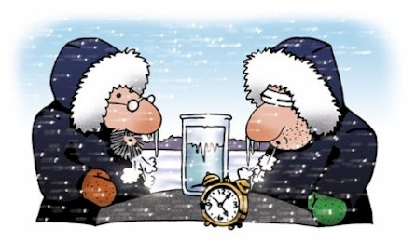

The sun was warm but the wind was chill. You know how it is with an April Day When the sun is out and the wind is still, You're one month on in the middle of May. But if you so much as dare to speak, A cloud comes over the sunlit arch, A wind comes off the frozen peak, And you're two months back in the middle of March.

From Two Tramps in Mud Time (1936) Robert Frost

When we think of sensations that stir people to write poetry, a bitter wind doesn't exactly spring to mind. On the contrary, it is almost universally despised, because it makes outdoor life in the Canadian winter less comfortable, and in many cases, much more dangerous.

We hear about **wind chill** on radio and television weather forecasts all winter long. But what is it??

Canada took the lead in an international effort to develop a **new wind chill formula**. In April 2000, Environment Canada held the first global Internet workshop on wind chill, with more than 400 participants from 35 countries. Almost all agreed on the need for a new international standard for measuring and reporting wind chill that was more accurate, easy to understand, and incorporated recent advances in scientific knowledge.

In 2001, a team of scientists and medical experts from Canada and the U.S. developed a new wind chill index, which is based **on the loss of heat from the face** - the part of the body that is most exposed to severe winter weather. The research agency of the Canadian Department of National Defence, with its knowledge of how troops are affected by cold weather, contributed to the effort by conducting experiments using human volunteers. They were dressed in winter clothing, with only their faces exposed directly to the cold, and exposed to a variety of temperatures and wind speeds inside a refrigerated wind tunnel. To simulate other factors affecting heat loss, they also walked on treadmills and were tested with both dry and wet faces.

The new wind chill index developed from this research is expressed in temperature-like units. However, since the wind chill index represents **the feeling of cold on your skin, and is not actually a real temperature**, it is given without the degree sign (for example, "Today the temperature is -10°C, and the wind chill is -20"). This index is also being used in the United States, but is provided on the Fahrenheit scale. The coldest wind chill in Canada (on record) occurred at Kugaaruk (formerly Pelly Bay), Nunavut, on January 13, 1975. On that day, the air temperature was -51°C, and the winds were 56 km/h, resulting in a wind chill of -78. To compare, this would have been -92 under the previous wind chill calculation system.

### Warning!

Wind chill warnings are issued by Environment Canada at varying values, depending on where you happen to be. In parts of the country with a milder climate (such as southern Ontario and the Atlantic provinces except Labrador), a wind chill warning is issued at -35. Further north, people have grown more accustomed to the cold, and have adapted to the more severe conditions. Because of this, warnings are issued at progressively colder wind chill values as you move north. Most of Canada hears a warning at about -45. Residents of the Arctic, northern Manitoba and northern Quebec are warned at about -50, and those of the high Arctic, at about -55.

So how do we protect ourselves against wind chill? Basically, the answer is to stay dry, and remove the wind component using shelter or clothing. Cover exposed areas, and minimize the time that bare skin is open to the elements by wearing gloves, mitts, scarves and hoods (incidentally, the fur around the hood of your favourite down parka is not there for looks - it creates a large boundary layer around the face to help reduce the effect of cold and wind).

Awareness and education are also important in preventing injuries related to cold, and Environment Canada has produced some great tools to help. First, you have to be aware of what you're dealing with for actual wind chill. This is available in two ways; by accessing weather reports, or determining the value from the new Wind Chill Calculation Chart from Environment Canada (Figure 1). The average person's skin begins to freeze at a wind chill value of -25, and freezes in minutes at -35 - keep these numbers in mind as a rough guide. To more accurately determine the risk, Environment Canada has produced a chart to help calculate the approximate exposure time before frostbite occurs (Figure 2).

### Figure 1:  Wind Chill Calculation Chart

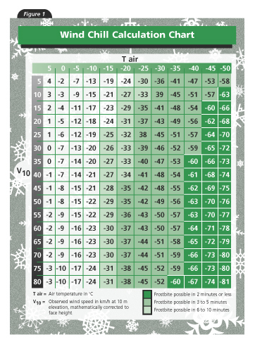

### Figure 2: Minutes to Frostbite (for the 5% most susceptible segment of the population)

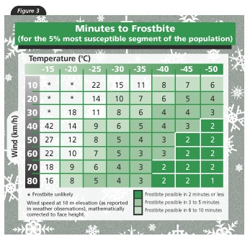

**Working Out Frostbite:**

* 1. It is -40 and you decide to run to your house at lunchtime. It takes 9 minutes to run to your house from school. Will you likely get frost bite?
  2. It is -15 and you are outside in a 10km/h breeze. Are you likely to get frostbite?
  3. It is -30 and you are on a skidoo that is travelling at 60 km/h. How long will it take you to get frost bite?
  4. At what temperatures and windspeeds do you need to be really aware of the possibility of getting frostbite?
  5. You can walk to most places in Dawson in 15 minutes. At what temperatures and windspeeds do you need to be very careful of getting frostbite in 15 minutes?
  6. Explain why some people choose to drive their vehicles much slower in winter when travelling.
  7. Explain the why the truck below has the front-end cover.

